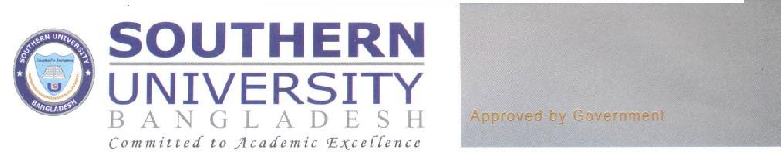

September 22, 2021

The Registrar

Southern University Bangladesh

New/471, University Road, Arefin Nagar

Baizid Bostami, Chattogram

**Subject: Regarding Orientation Program of Fall-2021.**

Dear Sir,

It gives me immense pleasure to inform you that the Faculty of Arts, Law & Social Science has planned to organize a virtual **Orientation Session** for the newly admitted students of Fall-2021 semester on **24th September, 2021, Friday at 09.30am**. In this regard, a verbal approval has been taken from the honorable Vice Chancellor of the University. The other distinguished guests have also consented to attend the program on that day. Hence, we need a formal approval from the Registrar’s office for the smooth conduct of the program.

Therefore, we look forward to getting your approval for the said program.

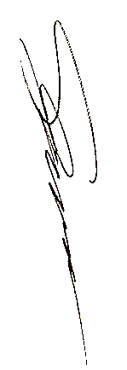

Thanking You,

Prof. Dr. Shrifuzzaman

Convener of the Orientation Committee

Dean

Faculty of Arts, Social Science & Law

Southern University Bangladesh 